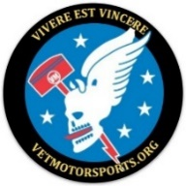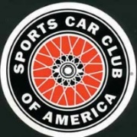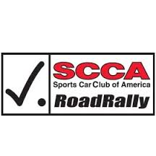

**Scare for a Cure**

Austin nonprofit raising money for local cancer charities

**Saturday**

**12 October, 2019**

Registration 4:00 -5:00 PM

Safety Briefing 4:45 PM

First Car out 5:01 PM

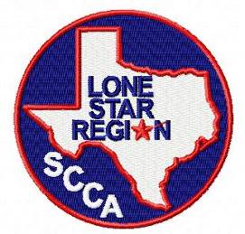

**Join The Lone Star Region of SCCA, VETMotorsports, and Scare for a Cure in Austin, Texas for a Ghost Town Road Rally.**

|  |  |  |
| --- | --- | --- |
| **Start**  5:00 PM, Saturday 12 October from J Lorraine’s Ghosts Town, 14319 Littig Road, Manor, Texas | **A 2 hour Route**  A non-speed event along scenic country roads and over charming bridges. | **Destination**  The Ghost Town Bar and Grill, 14319 Littig Road, Manor, Texas |

Each car must have at least two people, a valid driver’s license, a current inspection sticker and proof of insurance.

Rally Fee: $20.00 per car for SCCA Members and $20.00 per cars of non-SCCA members (you are a weekend member).

Minor Children (<18) are welcome but a Minor Waver signed by both parents will be required.

If you have any rally questions, contact the Rally Organizer, Ken McElroy, [Aggsip67@yahoo.com](mailto:Aggsip67@yahoo.com).

|  |
| --- |
| https://b.kisscc0.com/20180813/zpq/kisscc0-haunted-house-ghost-silhouette-drawing-haunted-house-silhouette-5b71456f9a34f5.5707592815341499996316.png  **12 October,2019 SCCA Ghost Town Road Rally**  **This Non speed will start and end at L.Lorraine Ghost Town but the 66 mile route will take you through lovely central Texas and over several pictographic bridges. The route is on paved roads in Bastrop, and Travis counties through such forgotten towns as Sayersville, Kimbro, Littig, Young’s Prairie, and Hogeye. Join us in costume for Halloween fun.** |
| Image result for ghost horse black and white  **Get ready for Halloween with this Ghost Ride (we guarantee at least one ghost) through Central Texas. Rally scores will be based on observations made along the route. After the Road Rally, awards will be given for best costumes along with a number of automotive themes. Stay with us after the rally to tour the J. Lorraine, Texas Ghost Town and to participate in either the “Scare For A Cure” Bone Yard Maze ($10/each) or their highly rated Main Haunt ($45/each). “Scream for a Cure” donates all profits to local cancer charities.** |

Registration starts 4:00 PM

Safety Briefing 4:45 PM

First Car off at 5:01 PM

All entrants must have:

1. Car with valid inspection sticker
2. current insurance

3) 2 people who can read.

|  |
| --- |
| Registration Options |
| **BEST** Use clubregistration.net at <https://clubregistration.net/events/signUp.cfm/event/10139> to register and pay online. |
| **Not as Good** Contact the Ken McElroy, at [Aggsip67@yahoo.com](mailto:Aggsip67@yahoo.com) and pay at the event |
| **OK** Show up and pay at the event |

This rally is sanctioned as a Regional Rally by SCCA will no count for points, Sanction Number 19-SRG-7581.

Towards the National SCCA Road Rally Championship. T**he Lone Star Region of SCCA at** [www.lonestarscca.org](http://www.lonestarscca.org) and <https://www.facebook.com/LoneStarSCCA/> **and is affiliated with the Sports Car Club of America (www.scca.org). SCCA has over 65,000 members, and offers car related activities in a broad range of automotive events.**

**The GOAL of the SCCA is to Have Fun in Cars!**